BJT Amplifier Homework 1 (18 points)
(jas, BJT Amplifier HW1.docx, 11/10/2025)

Clearly indicate answers and include units for numeric answers, using 3 or 4 significant figures. Show at least the major steps of your work so that if necessary partial credit can be awarded.
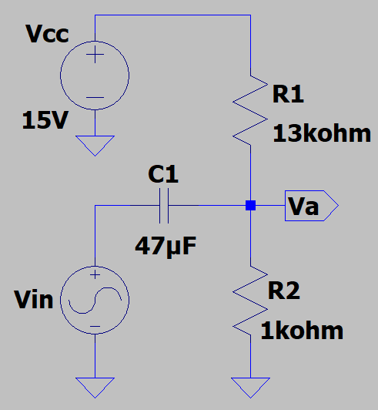
- Determine the frequency f associated with X_{C} < 0.1Req, in the adjacent circuit, recognizing that good coupling occurs for f greater than this minimum frequency. Be sure to include units in your answer. (Hint: Calculated minimum frequency should be < 100 Hz.) (4 points.)

Good coupling occurs for f > $36.47 Hz$
$$R_{eq}=13kΩ∥1kΩ=\frac{\left(13\right)\left(1\right)}{14}=\frac{13}{14}kΩ$$
$$X_{c}<0.1R_{eq}→0.0929kΩ$$
$$X_{c}=\frac{1}{2πfc}→f=\frac{1}{2πCX_{c}}=\frac{1}{\left(2π\right)\left(47*{10}^{-6}\right)\left(0.0929kΩ\right)}=36.47 Hz$$
$$f=36.47 Hz$$

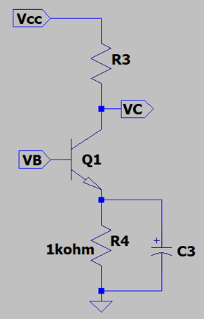
- Determine the smallest capacitor value for C3 necessary to provide good bypassing of resistor R4 at f ≥ 20 Hz for the adjacent circuit using standard 10% capacitor values. Standard 10% capacitor values are limited to the following increments per decade of capacitor values: 10, 12, 15, 18, 22, 27, 33, 39, 47, 56, 68, and 82. So for example, 15 µF, 18 µF and 22 µF are all standard 10% values. Be sure to include units in your answer. (Hint: Calculated capacitance value should be > 50 µF.)
(4 points.)

$$X_{c}<0.1R→X_{c}<100Ω$$
$$X_{c}=\frac{1}{2πfC}→C=\frac{1}{2πfX_{c}}=\frac{1}{2π\left(20Hz\right)\left(100Ω\right)}=79μF$$
$$C=79 μF≈82μF$$

C3 = $82 μF$
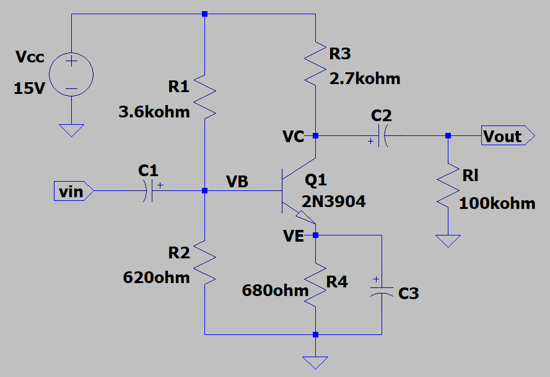
- For the adjacent Voltage Divider Bias (VDB) common-emitter amplifier circuit, calculate the following values assuming a β of 300 using simplified analysis. (Hint: A_{V} should be between
-240 to -225. (10 points total.)

- V_{B}. (2 Points.)
$$V_{B}=\frac{620Ω}{3600Ω+620Ω}\left(15V\right)=2.2V$$
$$V_{B}=2.2V$$

- I_{E} (2 Points.)
$$I_{E}=\frac{V_{B}-0.7V}{680Ω}=2.2mA$$
$$I_{E}=2.2mA$$

- r_{c} (2 Points.)
$$r_{c}=R3∥Rl=2.63kΩ$$
$$r_{c}=2.63kΩ$$

- $r_{e}^{'}$ (2 Points.)
$$r_{e}^{'}=\frac{25mV}{I_{e}}=\frac{25mV}{2.2mA}=11.36Ω$$
$$r_{e}^{'}=11.36Ω$$

- A_{V} (2 Points.)
$$A=-\frac{r_{c}}{r_{e}^{'}}=\frac{2.63 kΩ}{11.36 Ω}=-231.4$$
$$A=-231.4$$

